

BMW Car Sales Analysis (2010–2024)

About Project: This project focuses on analysing BMW car sales data from 2010 to 2024 using Power BI and Python. The objective was to identify sales trends, pricing patterns, and customer preferences across different regions, colours, models, and fuel types. Power BI was used to create interactive dashboards that visually represent total sales, regional performance, and yearly comparisons. In parallel, Python—along with libraries like Pandas, Matplotlib, and Seaborn—was used for data cleaning, analysis, and generating additional visual insights such as average price trends and colour distribution. This end-to-end project demonstrates the use of data analytics tools to support business decisions and uncover valuable patterns in automotive sales data.

**Tools Used**

* **Power BI** – For interactive dashboards and visual reports
* **Python** – For data analysis and custom visualizations
* **Pandas** – For data cleaning and manipulation
* **Matplotlib & Seaborn** – For plotting graphs and trends
* **MS Excel / CSV** – As the source file format for raw data

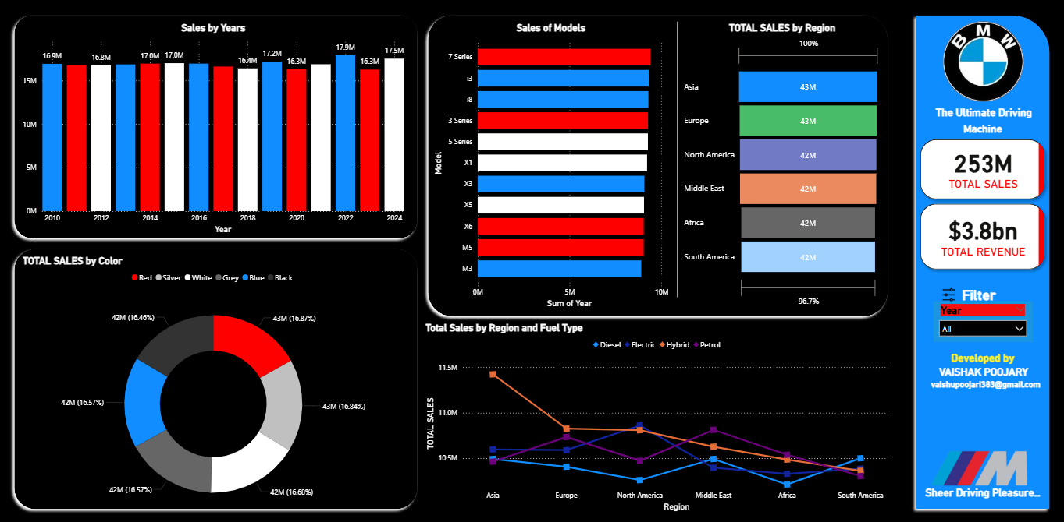

**📊 BMW Car Sales Dashboard (Power BI Visualization)**

**Description:**  
This interactive dashboard was built using **Power BI** to analyse the sales performance of BMW cars from 2010 to 2024. It presents a comprehensive view of key metrics such as:

* **Sales by Years** – Bar chart comparing yearly sales volume.
* **Sales by Models** – Horizontal bar chart showing popular models.
* **Total Sales by Region** – Stacked bar showing regional distribution (Asia, Europe, North America, etc.).
* **Total Sales by Colour** – Donut chart visualizing sales by car color.
* **Fuel Type by Region** – Line chart comparing sales of Diesel, Electric, Hybrid, and Petrol variants.
* **Summary Cards** –
  + 🧮 **Total Sales:** 253M
  + 💰 **Total Revenue:** $3.8B

**Tools Used:** Power BI, DAX, Excel (for data cleaning), and slicers for dynamic filtering.



**🐍 Python Data Exploration (Code Snippet)**

**Description:**  
This screenshot shows the use of **Python** for initial data exploration and preprocessing. A CSV dataset containing 50,000 rows was loaded using **Pandas**. Key steps include:

* Importing required libraries: seaborn, matplotlib, and pandas
* Loading the BMW dataset using pd.read_csv()
* Previewing the dataset, which contains:
  + Model, Year, Region, Color, Fuel_Type
  + Engine_Size_L, Mileage_KM, Price_USD, Sales_Volume, Sales_Classification

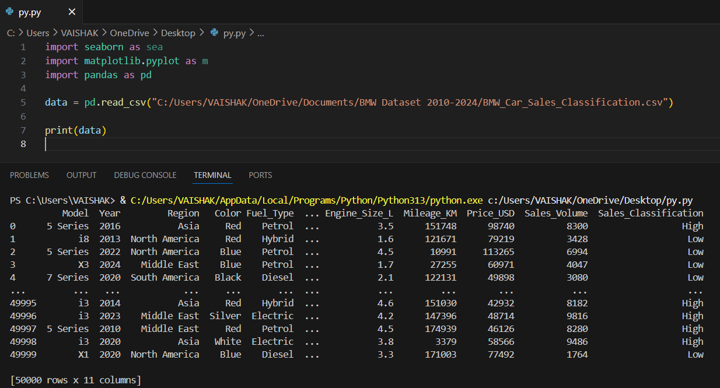

**📊 BMW Sales Dashboard & Price Analysis Report**

**🔹 Overview of BMW Sales Dashboard**

The BMW Sales Dashboard provides a comprehensive visual analysis of the company's performance in 2024. The dashboard includes the following key insights:

* **Total Sales**: 18 Million units
* **Total Revenue**: $257.1 Million
* **Sales by Year**: 2024 alone recorded 17.5M units sold, indicating a massive annual contribution.
* **Sales by Models**: The BMW X6 model led in sales, followed by the 5 Series and 7 Series.
* **Sales by Color**: Most popular car colors were White (17.39%), Grey (17.17%), and Red (16.33%), each with around 3 million units sold.
* **Sales by Region**: Each major region including Asia, Europe, North America, and the Middle East reported approximately 3M units in sales, showcasing global demand.
* **Fuel Type vs Region**: Petrol and Electric vehicles dominate across most regions, with Diesel being less popular in some areas.

This dashboard was designed and developed by **Vaishak Poojary**, integrating modern visuals with business intelligence tools to track performance metrics efficiently.

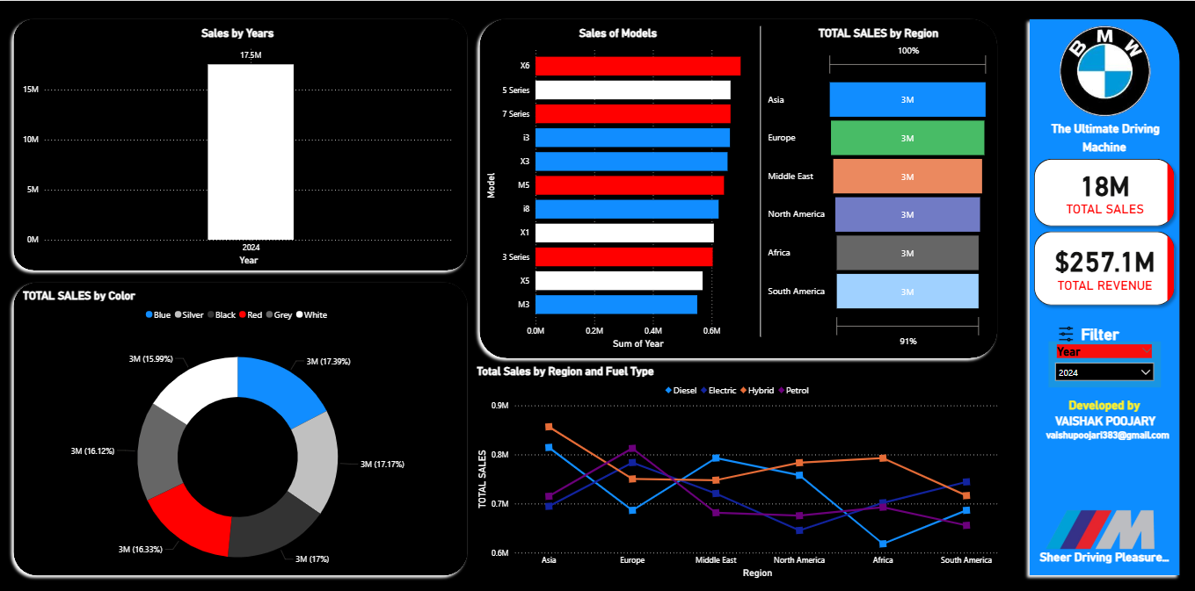

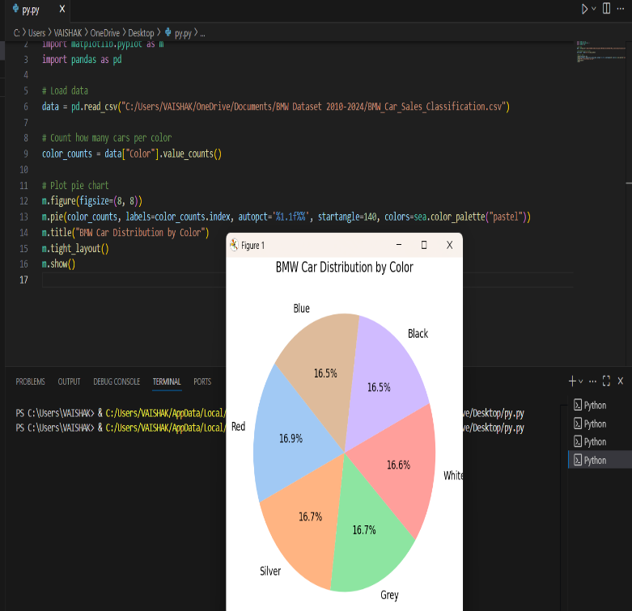**🔹 Python Code for Price Trend Analysis (Image 2)**

The second image illustrates a Python-based analysis that calculates and visualizes the **average BMW car price from 2010 to 2024** using the pandas, matplotlib, and seaborn libraries.

* **Data Used**: BMW_Car_Sales_Classification.csv containing year-wise price data.
* **Processing**:
  + Data grouped by year
  + Calculated the mean price (Price_USD)
* **Visualization**:
  + A green bar chart representing yearly average prices with black borders
  + Title: *"Average BMW Price by Year"*

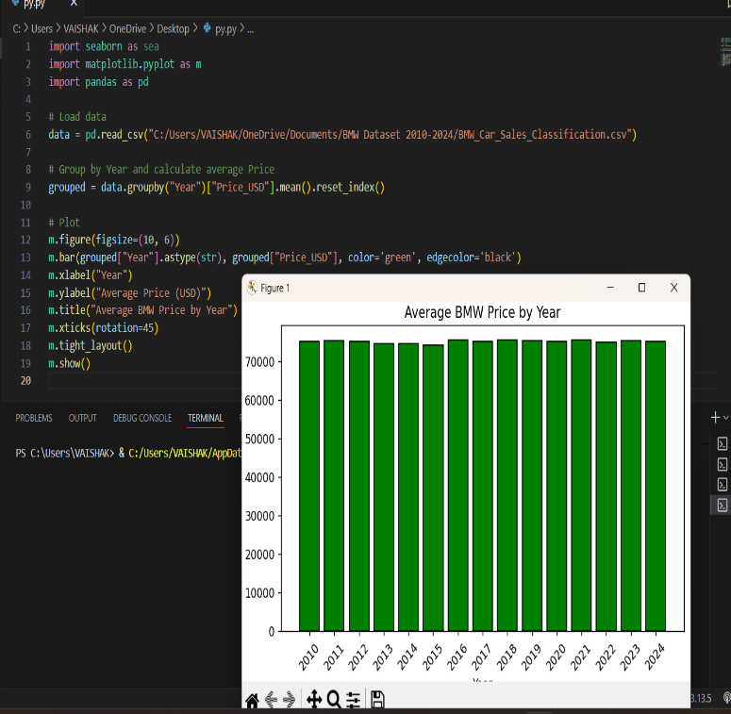The graph indicates that the average price remained relatively stable over the years, hovering around $75,000. The code is concise, efficient, and ideal for trend analysis in pricing strategies.

**Conclusion**

This project highlights the use of data visualization and Python-based analysis to derive valuable business insights from BMW’s global sales and pricing data. The Power BI dashboard effectively displays regional, model-wise, and color-wise sales trends, while the Python chart offers a clear view of average price stability over time. Together, these tools reflect a powerful approach to data storytelling and decision-making.

**👤 Prepared By:**

**Vaishak Poojary**  
📧 Email: vaishupoojari383@gmail.com  
📞 Phone: 9136719084  
🔗 LinkedIn: [linkedin.com/in/vaishak-poojary](https://www.linkedin.com/in/vaishak-poojary/)  
💻 GitHub: [github.com/VaishakPoojary](https://github.com/VaishakPoojary)